**Project Design Phase-I**

**Solution Architecture**

|  |  |
| --- | --- |
| Date | 19 September 2022 |
| Team ID | PNT2022TMID32392 |
| Project Name | CHILD SAFETY MONITORING GADGETS BASED ON IOT |
| Maximum Marks | 4 Marks |

**SOLUTION DESCRIPTION:**

* In the system the collected information from the temperature sensor and GPS are used to detect the status of the child and alerts the respective guardians using GSM accordingly**.**
* Child safety monitoring makes parents to easily monitor their children in real time just like staying beside them as well us focusing on their won career without any manual intervention.
* Basically children cannot complain about abusements which they face in their daily life to their parents,so it is very usefull for child safety.
* Especially the focus on providing information to migrant at all stages of migration along migration routes. Establish information points that can refer migrants to child sensitive with responsive support options**.**

Cellular GSM Network

IOT

**MOBILE PHONE**

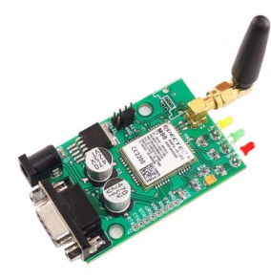

**GSM module**

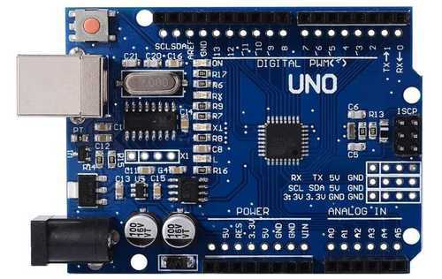

**Arduino UNO**

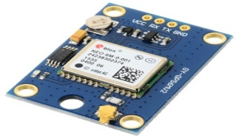 Buzzer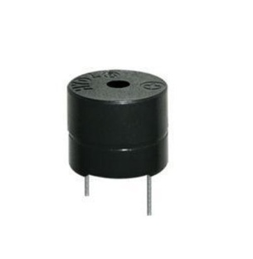

GPS sensor

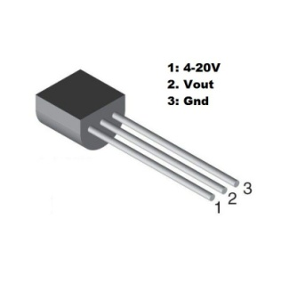

Temparature sensor